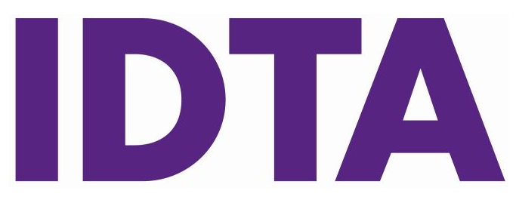
International Dance Teachers’ Association
International House 76 Bennett Road Brighton BN2 5JL
Tel: 01273 685 652 Email: ukexaminationrequests@idta.co.uk

In person

Live Stream

Video

REQUEST FORM - THEATRE Studio Examination Session
This form must reach us at least EIGHT WEEKS before the actual date required for the examinations
Report Forms will not automatically be sent, unless requested by you. The procedure for examination sessions is described in the appropriate syllabus.

The fees for each daily session must amount to a minimum of £425 for an in-person exam session or £225 for a live-stream exam session. Please note that you must inform Head Office immediately should you wish to cancel an examination session. A charge of £150.00 will be applied if teachers fail to notify Head Office at least two weeks prior to the date of the examination.

* Professional Application Forms and fees must accompany this form.
The number of exams stated may not vary by more or less than 10% on the session day.
Anatomy Application forms must also be sent to head office six weeks prior to examination date.
If you are only entering professional examinations and your total exam fees are less than £200.00 you will be required to pay the special examination fee of £134.00.
Is this your first exam session YES/NO

Date(s) of Session (Preferred)……...……..…..…….… Day………………….………… No of Days Req…...…..…………………...

Start Time……..…………… Finish Time (approx) ………………… Alternative Date(s)………….………………….…………………………………..

Name of principal Mr. / Mrs. / Miss. ………………………………………………………………………………………..…………………………………………..….……

Preferred Invoice Email ……………………………………………………………………….…………………………………………………………………………………………
Full address and postcode of place of examinations .Please let us know if your studio is on a ground floor, or are there are any steps up or down to your studio.

…………………………………………………………………………………………………………………………………………….……………Postcode…………………………………

Teacher/Venue/Studio telephone number ……………………………………………………………………………………………………………………………..…..
Please state, in a maximum of five words, the name of your school as you wish it to appear on
awards and certificates…………..………………………………………………………………………………………………………………………..…………………………..

Are you prepared to accept examination entries from another IDTA School? YES / NO

Signature of principal …………………………..…………………………………..………….. Membership No……………….……………………..

PLEASE INDICATE IF YOU WOULD LIKE YOUR SESSION RESULTS SENT TO YOU VIA EMAIL. YES/NO

A SEPARATE REQUEST FORM MUST BE COMPLETED FOR EACH SCHOOL INVOLVED
THEATRE BRANCHES
*Professional application forms for Associate, Licentiate, Fellowship and Diplomas must accompany this Request Form
 | Cert | Inter | Adv. 1 | Adv .2 | New Pre Ass O/Seas only | Level 3 Diploma | Exams with No Anatomy* | *Assoc/Level 4 | *Lic | *Fellow | *Diploma
MT Performer
Musical Theatre
Ballet
Tap
Theatre Craft
Cont M. Jazz
Freestyle only
Freestyle
Street Dance
Cheerleading
Line Dancing
Rock’n’Roll
Dance Exercise
Belly Dance
Acrobatic Dance
Anatomy
*Exams with no Anatomy – Please tick this box if the candidate has an existing Associate Freestyle qualification

(EXAMINER ONLY) VERIFY IDENTIFICATION

THEATRE BRANCHES - GRADES AND DANCE AWARDS
The number of exams stated may not vary by more or less than 10% on the session day.

SEPARATE REQUEST FORMS MUST BE COMPLETED FOR EACH SCHOOL INVOLVED.

PLEASE ENTER THE AMOUNT REQUIRED IN NUMBERS
Normal tests, juniors & adults | BALLET | TAP |  | THEATRE CRAFT |  | CONT. MODERN JAZZ/ | ACROBATIC DANCE | GENERAL DANCE PROGRAMME |  | FREESTYLE GRADES
Preparatory
Primary Grade
Grade One
Grade Two
Grade Three
Grade Four
Grade Five
Classical Award 1
Classical Award 2
T.A.P Award
First Steps Award
Juvenile Award
Preliminary Medal
Bronze
Silver
Gold
Gold Bars and above
Adult Medal Tests
Adult Duo / Trios
Team Awards
Duo / Trios
Classwork Assessment
Rosettes / Musical Theatre Rosettes |  |  |  |  | CHEERLEADING
Theatre Star Awards / Stardance |  |  |  |  | Rosettes………………..… Stardance ………………  Solo …………….  Ground Bound Teams …………
River Dancing
Dance Exercise/Schools and General
Freestyle
Freestyle Pairs/Trios
Freestyle Teams
Street Dance
Rock ‘n’ Roll
Line Dancing
Musical Theatre Syllabus
Musical Theatre Medals |  |  |  |  | TOTAL NUMBER OF EXAMS: ………………
Musical Theatre Acting Awards
PLEASE TICK THIS BOX IF YOU WOULD LIKE THE NEW AMATEUR MEMBERSHIP CARDS FOR YOUR PUPILS |  |  |  |  | The examination session must be timed according to the published syllabus. These are set for each grade and medal test. Principals must supply to the Examiners, in advance, a correct timetable including breaks.  Total Time Duration for session ……..…….. hours

By submitting this form you consent to the information being used as described in our Privacy Notice.
The information will only be used in accordance with the General Data Protection Act. Please see www.idta.co.uk/privacy-notice for details.
Filming and photography policy in all IDTA exam sessions Amateur & Professional.
To prioritise the safety and well-being of all participants, we are prohibiting any filming or photography during open exam sessions, with immediate effect. This decision will not only help prevent potential abuses of images or footage but will also help maintain a focused, respectful, and secure environment for everyone involved.

